6.1 Application Control

XGene 360 will be a web-based application accessible through a web browser. The user will be navigating through a series of PHP pages hosted on a server in order to use the application. The screenshot below is a sample of the general visual interface of a typical page:

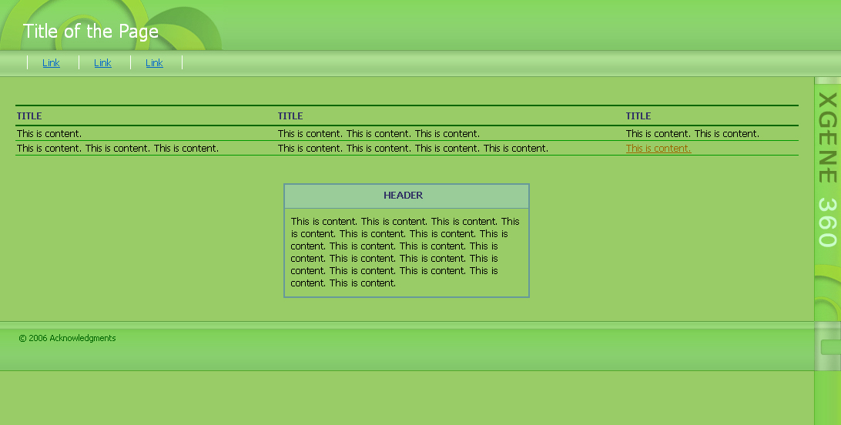

Figure 1: Screenshot of General Page

6.1.1 Common Look and Feel
The name of the application will be displayed on a vertical bar on the right side of the browser screen. The header portion will be situated on top and will display a plant graphic. Page titles will be displayed on the left corner of the header. Below the header will be the navigation bar, which will display links available to the user to select from. These links will vary from user-to-user. The content of the page will be displayed underneath the navigation bar and will vary from page-to-page. In terms of content, there will be the use of common table types, such as a table for listing objects or a table for displaying instructions. Underneath the page content will be the footer bar. The footer bar will only contain copyright information.

6.1.2 Common Behaviour
Since the application will be accessible through a web browser, user interaction will be similar to browsing any other web page on the Internet. The user will be able to use a mouse to select links in order to view other pages and select checkboxes and dropdown menus. With a keyboard, the user will be able to type input in form fields.

Upon initial access of the application, users will be brought to the login page. After entering the correct username and password combination, a list of problems associated with the user will be displayed. The user will then be given the freedom to browse the application.

6.2 Screens
The application will consist of numerous pages. For the sake of conciseness and clarity, the screens will be categorized by page function, such as viewing course details or login. There will not be a screen for every single page. Instead, there will be selected screens for each page function category.

6.2.1 Screen Venn Diagram
A Venn diagram is generally used to show relationships between sets, which are represented by circles that intersect with each other. This diagram will be chosen over a transition diagram to display flow control because there will be multiple ways to access a certain page. A transition diagram for this application will be very confusing as a result. A Venn diagram will provide a cleaner view.

Each circle of the Venn diagram will represent a user. Inside each user circle will be the pages that each user will be able to access. Overlaps of circles will display the pages that several users will have access to. The numbers in the overlapping sections correspond to the last number of the sections below the diagram (i.e. the number “1” corresponds to 6.2.1.1). A detailed explanation of each page will be shown in subsequent sections 6.2.2-6.2.9.

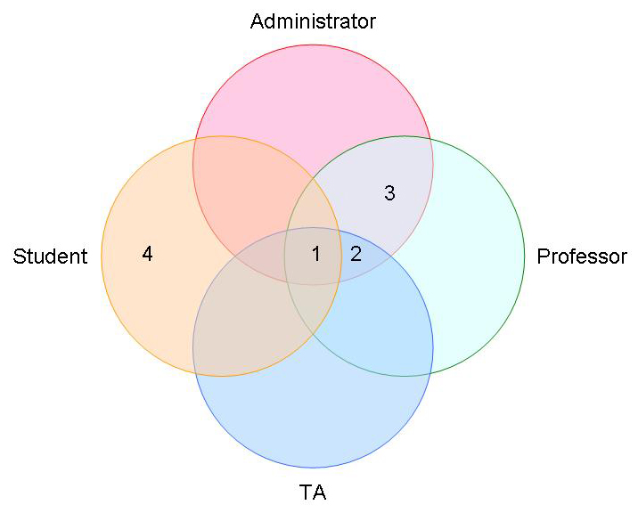
Figure 2: Screen Venn Diagram

6.2.1.1 Common Pages for All Users
Login
Logout
Change Password
List of Problems
Problem Details
Problem Solution Details

6.2.1.2 Pages for Administrator, Professor, TA
List of Students
Student Details

6.2.1.3 Pages for Administrator, Professor
List of Courses
List of Problems
List of Professors
List of TAs
Course Details
Professor Details
TA Details

6.2.1.4. Pages for Student
List of Generations
Submit Problem

6.2.2 Login
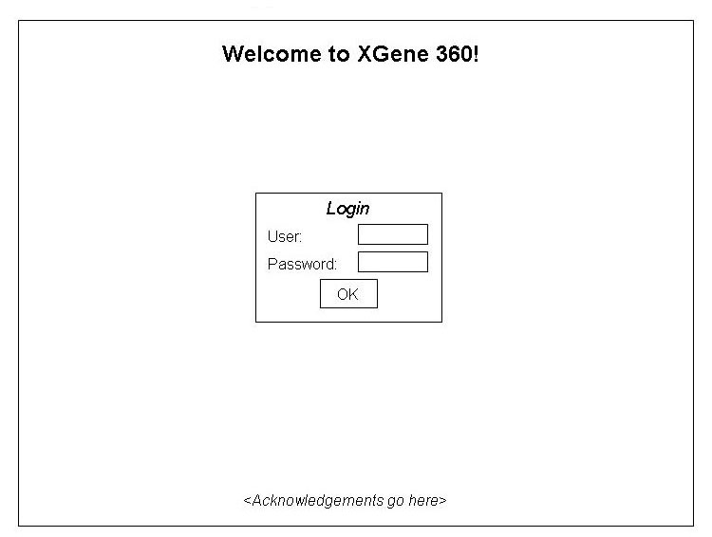
Figure 3: Login

Name | Login
Description | The first page a user will see. It will allow a user to login to the application.
Users | Administrator, Professor, TA, Student
Inputs | - Username  - Password
Outputs | The application will accept login information and bring the user to a list of problems that the user is associated with.
Possible Errors | An invalid login will result in a message indicating that the information is incorrect.

6.2.3 Logout
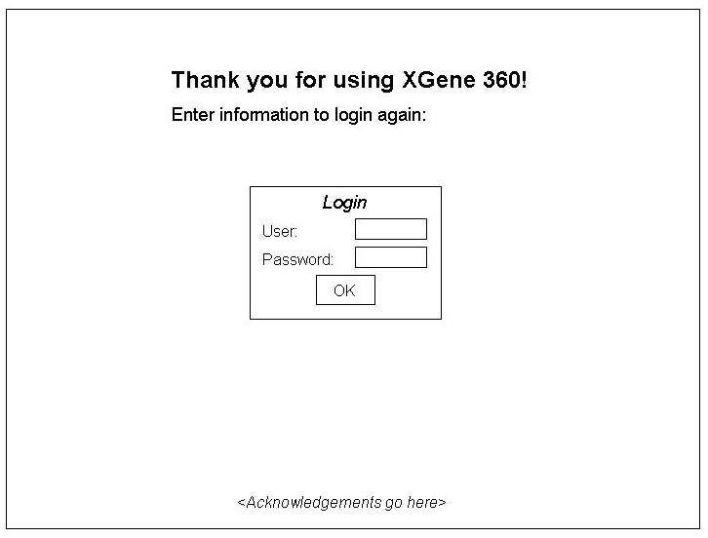
Figure 4: Logout

Name | Logout
Description | To logout, a user will press a button labelled “Logout” and will be directed to the logout page.
Users | Administrator, Professor, TA, Student
Inputs | None
Outputs | The application will log out of the user’s account and show the logout page, which will give the user an option to login again.
Possible Errors | None

6.2.4 Change Password
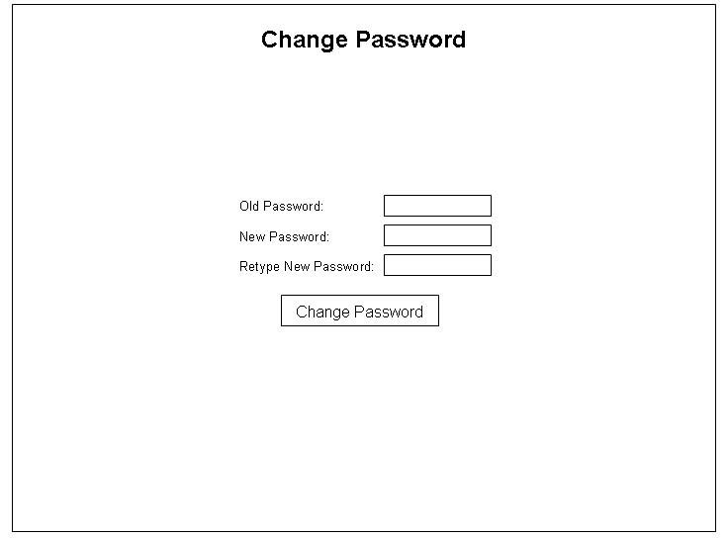
Figure 5: Change Password

Name | Change Password
Description | User will be able to change his/her password.
Users | Administrator, Professor, TA, Student
Inputs | Old password, New password (twice)
Outputs | After clicking the “Change Password” button, the user’s new password will become the current password.
Possible Errors | Errors will result in the clearing out of the fields in order for the user to fill out the information again. Errors will be caused by the following:  - The old password is invalid  - The “New Password” and “Retype New Password” fields do not have the same input

6.2.5 Lists
There will be several types of lists for objects such as students and courses. The tables that will display the objects will all have a similar interface. Differences in the content of the tables will depend on two things – the type of the object and the type of user viewing the list.

For each object, there will be table fields that will be relative to the object. For example, a list of problems will have table fields such as “Start Date” and “Course” while a list of generations will have table fields such as “Histograms” and “Parents”.

Students and TAs will be able to click on object’s name in a list to view a page of the details for the particular object.

The administrator and professors will also be able to click on an object to view the object’s details. In addition, the administrator and professors will be able to create and manage objects. The option to create an object will be shown as a link labelled as “Create [Object]”, where [Object] will be replaced by the actual object type (i.e. Course/TA). Upon clicking the link, a form will appear within the same page with form inputs for the user to fill out. To modify/delete a particular object, the user will click the object to view the details. On the details page, the user will be able to modify certain fields and press the “Modify” button to submit the changes or simply delete the object by pressing the “Delete” button. The user will also be able to do modification in batches by selecting several objects via checkboxes.

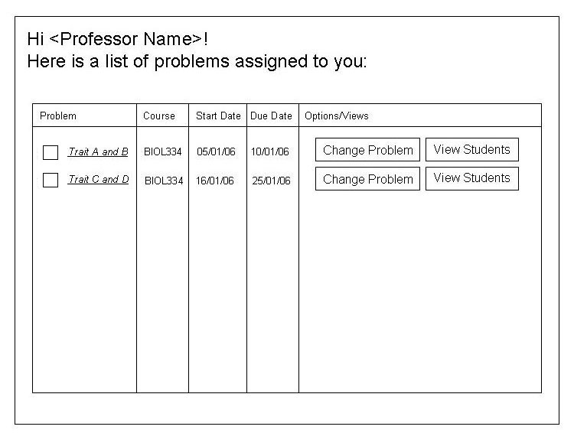
Figure 6: List of Problems for Professor

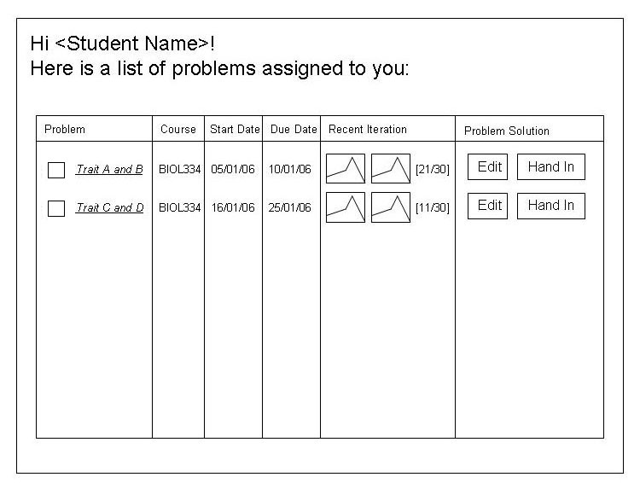
Figure 7: List of Problems for Student

Name | List of Problems
Description | A user will be able to see a list of problems associated with the user. Details for each problem will be viewable by clicking on a problem name. User-specific options will be available as well.
Users | Administrator, Professor, TA, Student
Inputs | None
Possible Outputs | These will be the possible outputs, depending on the type of user:  - Changing problem parameters  - Viewing students and/or TAs assigned to problem  - Editing problem solution  - Handing in problem solution
Possible Errors | None

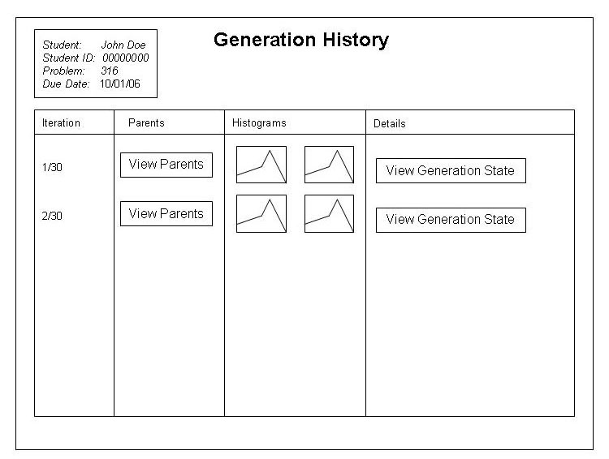
Figure 8: View Generation History

Name | List of Generations
Description | The user will be able to view a generation history for the current problem.
Users | Student
Inputs | None
Outputs | These will be the possible outputs, depending on the user’s selection:  - View the parents for the generation.  - View the problem state for that generation.
Possible Errors | None

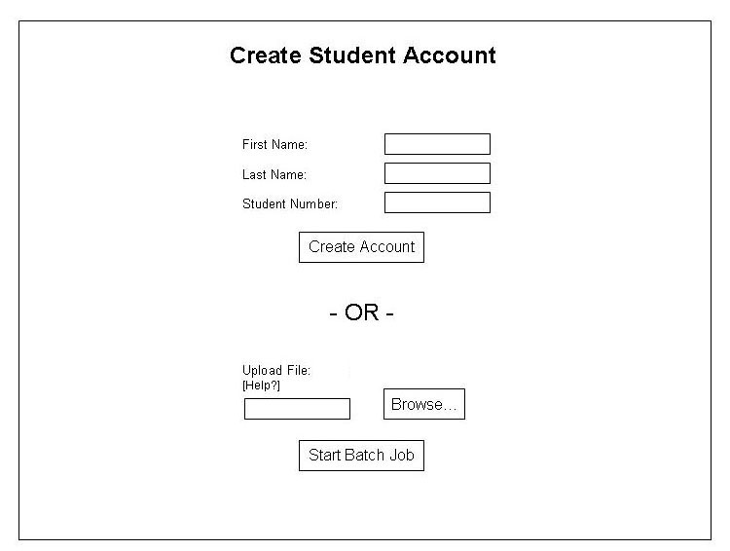
Figure 9: Create Student

Name | Create Student
Description | Will create a new student. This section will pop up within the list of students page when the user clicks a “Create Student” link.
Users | Administrator, Professor
Inputs | - First name  - Last name  - Password  - Assigned courses (optional)  The user will also be able to upload a text file with a list of student information.
Outputs | After verifying the inputs, the application will output a username and password. If the user provided an excel sheet, then a list of usernames and passwords will be provided.
Possible Errors | Invalid information will result in a message indicating that the information is incorrect.

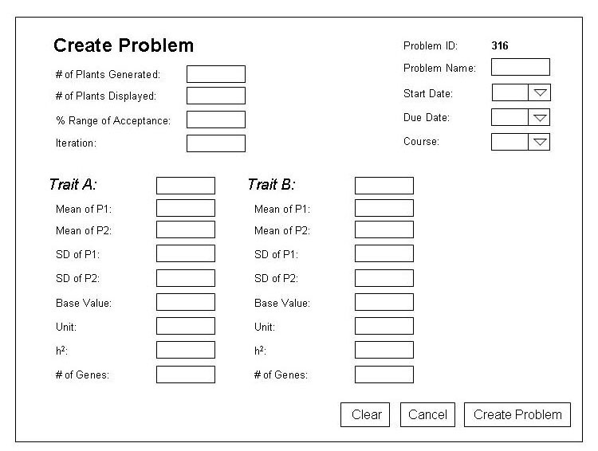
Figure 10: Create Problem

Name | Create Problem
Description | Will create a new problem. This section will pop up within the list of problems page when the user clicks a “Create Problem” link.
Users | Administrator, Professor
Inputs | Indicated by the above figure.
Outputs | After verifying the input, the application will output a message indicating success.
Possible Errors | Invalid field inputs will result in an error message.

6.2.6 Object Details
All objects in the application will have a page that outlines the object’s details. The content of each page will depend on the type of object.

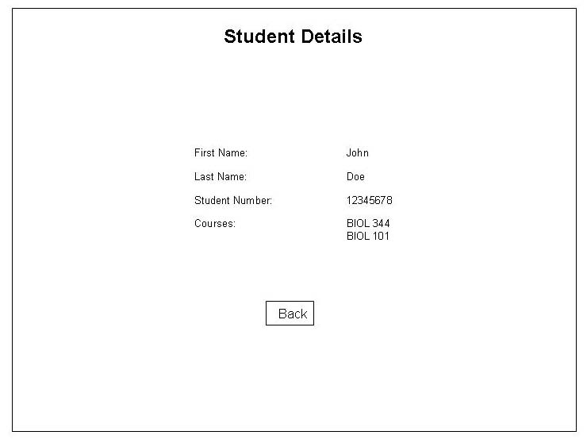
Figure 11: Student Details

Name | Student Details
Description | View the details of a particular student.
Users | Administrator, Professor, TA
Inputs | If the user is the administrator or a professor, these will be the possible inputs:  - First name  - Last name  - Password  - Assigned courses (optional)
Outputs | The application will lead the user back to the list of students. If the user is the administrator or professor, the application will verify the inputs as well.
Possible Errors | Invalid inputs will result in a message indicating that the information is incorrect.

6.2.7 Problem Details
There is a separate section for problem details because the interface is quite different from other object details.
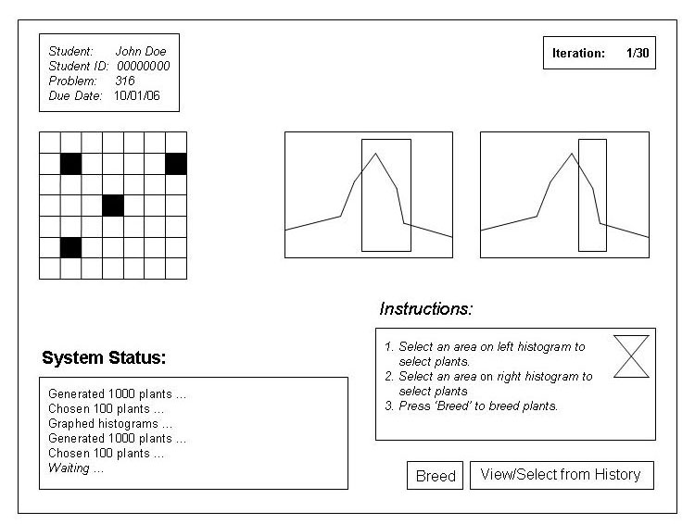
Figure 12: Problem Details for Student

Name | Problem Details
Description | The user will be able to view the details of a problem. If the user is a student and the problem is not finished, the user will be able to select plants for breeding.
Users | Administrator, Professor, TA, Student
Inputs | If the user is a student, the possible inputs will be:  - Seeds from areas highlighted from the grid. The highlights areas will come from the selected areas of the histograms.  - As an option, seeds from a previous generation
Outputs | If the user is a student and the problem is not finished, breeding will occur, and the problem details for the next generation will appear, allowing the student to continue.
Possible Errors | None

6.2.8 Problem Solution Details
There is a separate section for problem solution details because the interface is quite different from other object details.
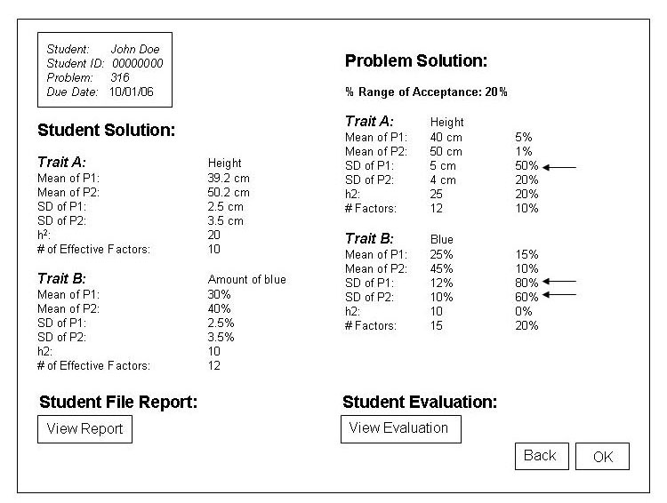
Figure 13: Problem Solution Details for Student with Feedback Returned

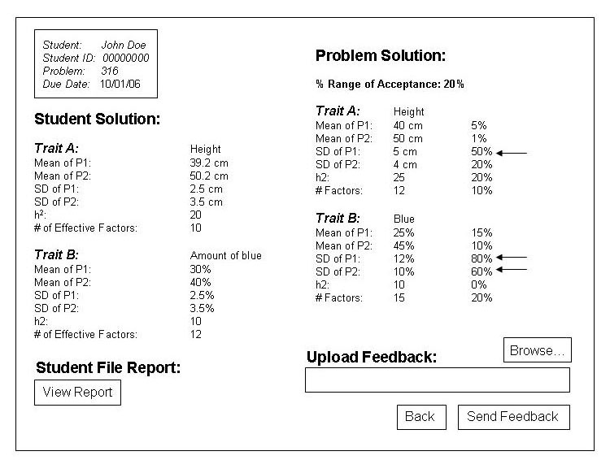
Figure 14: Problem Solution Details for Professor with Feedback Field

Name | Problem Solution Details
Description | The user will be able to view student results for a problem as well as any feedback from the professor or TA.  If the user is the administrator, a professor or a TA, the user will also be able to upload an evaluation/feedback file.
Users | Administrator, Professor, TA, Student
Inputs | If the user is the administrator, a professor or a TA, an evaluation/feedback file upload will be optional.
Outputs | If the user is the administrator, a professor or a TA, a prompt will pop up verifying the success of sending the evaluation.
Possible Errors | Evaluation file is invalid, so the application will output a message indicating that a valid file should be used.

6.2.9 Submit Problem
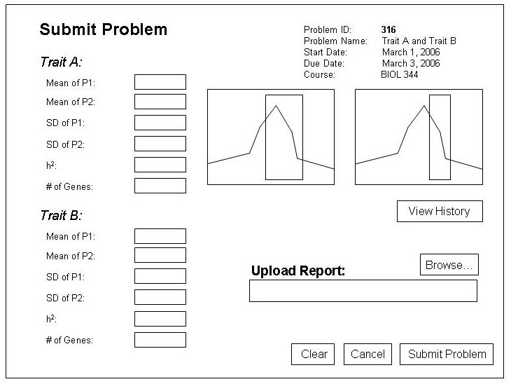
Figure 15: Submit Problem

Name | Submit Problem
Description | Will allow the user to submit solutions to a problem.
Users | Student
Inputs | Indicated by the above figure.
Outputs | After verifying the input, the application will output a message indicating success.
Possible Errors | Invalid field inputs will result in an error message. Also, if the report file is invalid, the application will output a message indicating that a valid file should be used.

